Faculty of Architecture, Civil Engineering and Transport Sciences
Department of Structural and Geotechnical Engineering

FINAL THESIS

The title of the thesis

THE NAME OF THE STUDENT
THE SEMESTER OF THE SUBMISSION

After the title page, the Final thesis requirements signed by the head of department and the internal consultant must be inserted.

Student’s declaration

The undersigned ..................................(name) (NEPTUN code ............................), student of.....................................................faculty, declare that the thesis/diploma work titled.......................................................... is a work of my own and I have only used sources indicated, in the proportion indicated and in compliance with the rules of citation with the exact indication of the origin of the citation
Győr, [date]

……………………………..
signature

Summary
A brief summary of the thesis of approximately one page, which should clearly show what the student had to solve, what information, starting data, solutions prepared by others, samples he received, what activities he performed, and what the result of the thesis was.

Table of contents:
1 Introduction 7
2 Body text format 7
3 Figure, image and table 7
3.1 Insert figure 7
3.2 Image numbering 8
3.3 Table properties 9
3.4 Equation 9
4 Citation 9
5 Bibliography 10

The table of contents of the thesis is automatically generated, in which the headings must be displayed up to 3 levels. The page number must also be displayed for all headings.

Introduction
This template provides guidelines for the formal appearance of final theses and diploma theses prepared at the Department of Structural and Geotechnical Engineering of the Széchenyi István University in Győr. The thesis must be divided into chapters and subsections, and the chapters must be numbered. The use of subsections is justified if at least two headings appear at the given level. For this, the "Headline" styles can be used, which also ensure automatic numbering.
The size of the final thesis is 50-80 pages without annexes (drawings and calculations). The most important calculations (results), figures, illustrations, tables can be inserted into the text in this size, it is part of the main content. In the case of calculations, their detailed documentation must be attached to final theses as an annex.

Body text format
The thesis must be prepared in A4 format, with a 2.5 cm margin on each side, and an additional 0.5 cm binding margin for binding on the left side. The thesis must be printed on one page.
The body text must be written in Monsterrat Light font, 12 pt font size, justified alignment.
The university's official font style can be downloaded from the department's website (if this is not available, the Tahoma font style can also be used). 1.15 line spacing should be maintained between lines, and 6 pt separation between paragraphs (Normal style).

Figure, image and table

Insert figure
If possible, figures in the text should be arranged in the middle, in one line with the text. Figures must be numbered continuously, which can be automatically generated with the "insert caption" option. In addition to the numbering, the figure caption also contains the title of the figure. Figures must always be referenced in the text.
Figure captions (image and table) must be centered, 11 pt font size, written in italics (caption font style).
(if you do not want to place the figure in the same row as the text, then both the figure and the figure caption must be placed in a common text box)
The figures must be constructed in such a way that they are transparent, readable and interpretable on their own. In the case of diagrams, the axes must be named, in the case of multiple data lines, their meaning must be presented with a legend..
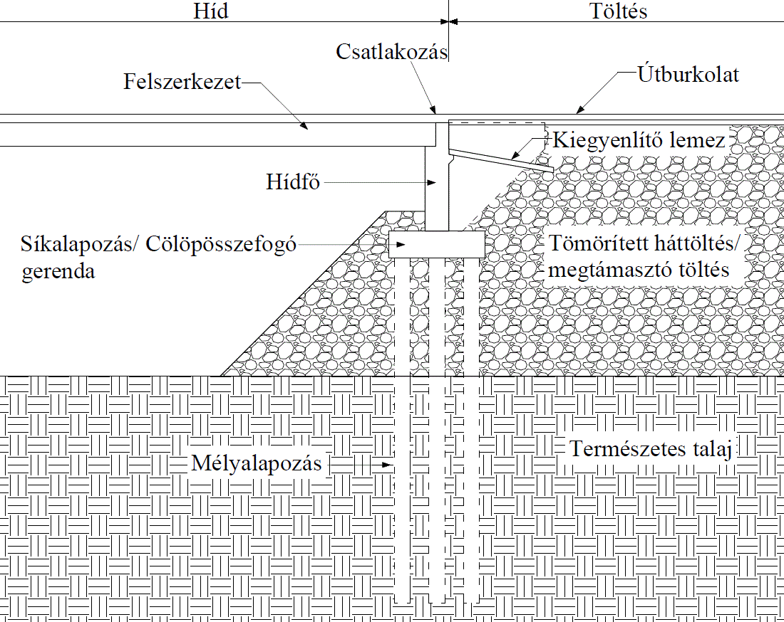
Fig. 1: Schematic drawing of bridgehead (Briaud et al., 1997)

Image numbering
The pictures should be arranged in the same way as the diagrams, and should also be numbered consecutively and identified by the name of the picture. All images should be referenced in the text.
Image 1: Logo of the Széchenyi István University

Table properties
Tables should be placed on the same line as the text and numbered automatically. The data in the table should be written in the same font (Montserrat Light) and size (12 pt) as the text. If there is too much text, the font size can be reduced to 11 pt. For text in a table, the 6 pt spacing between paragraphs does not apply (Table text style).
Table 1: Sample table
topic | length
introduction | 5 pages
discussion | 35 pages

Equation
The equations must be written using the equation editor built into the text editor, and they must be numbered continuously. The equations must be placed in the middle, and the numbering must be displayed at the end of the line, aligned to the right.
$σ=E∙ε$ 1. egyenlet

Citation
In the text, the data obtained as a starting point (plan sheets, starting data, etc.) do not have to be referenced separately in each place, but they must be listed in detail at the beginning of the final thesis. The content of these materials can be used, but their verbatim use in the thesis is prohibited.
The literature used to prepare the thesis (publications, books, articles, internet resources) must be collected in a bibliography at the end of the thesis, and they must be cited where they are used. In the bibliography, you can only use references to which there is a reference in the final thesis. It is recommended to use the name(s) of the author(s) and the year of publication for the form of the reference. (eg.: Bognár, 1997). The names of up to two authors must be indicated, for three or more authors the first abbreviation "author and co-authorsi" can be used. The serial number used in the reference may also be used.

Bibliography
At the end of the thesis, all the literature used and referred to in the text must be listed. It is recommended to make the list in alphabetical order according to the authors, and to use the author and year references in the text. If a reference with a serial number is used in the text, it is recommended to list in the order of the reference. The following formats are recommended for the bibliography:
book:
author(s) (year): title, publisher name, place of publication
Baddeley, A. D. (1997). Human memory: Theory and practice. Psychology Press, London, UK:.

folyóirat, cikk
author(s) (year): title, journal name, journal number (year, publication), page number
Ryan, J. D., Althoff, R. R., Whitlow, S., & Cohen, N. J. (2000). Amnesia is a deficit in relational memory. Psychological science, 11(6), pp 454-461.

